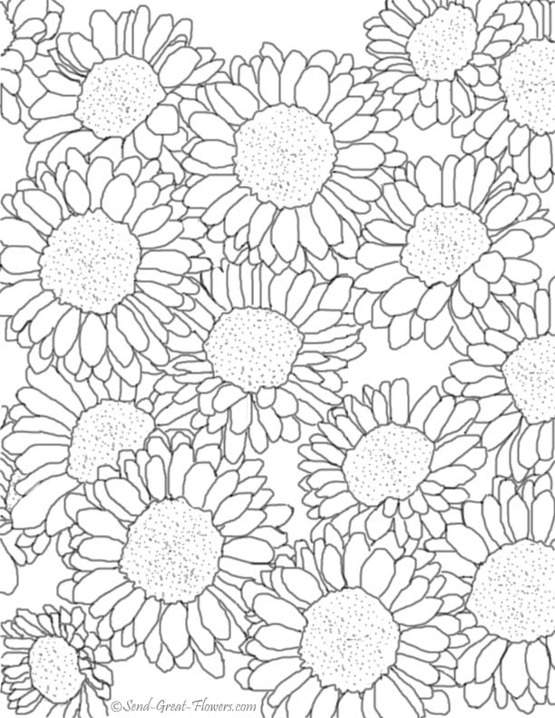

Mums

(from Paradise Nursery)

9” size pots

$6.00 per plant

Pre-Order Only by

Sept. 16th

Pick-up Date:

Sept. 27th

Name: _______________________________

Email: _______________________________

Color Choices:

___ Red ___ Yellow ___ Purple ___ White ___Bronze

Total number of plants: _____

Amount enclosed: $______

checks payable to Spring Glen PTA

Spring Glen PTA’s

Fall Plant Sale

* Order Form